P001 - CPX Dashboard

Summary
Business Owner (SME): | Security Office
Project Manager (DT): | Aizhan Ismailova
Data Refresh Frequency | Daily
Requested on | 14-May-2026
Estimated Effort : | 2 weeks
Azure DevOps Ticket: | n/a
Status | In Progress

Project Overview
In this project, I designed and implemented a complete end-to-end BI solution from SOC data. The project covered the full analytics development lifecycle—from requirements understanding and gathering to data cleaning, data modeling, transformation logic, the creation of an analytics-ready schema, and developing PBI dashboard. The dashboard provides two distinct user experiences — an executive view for strategic monitoring and an operational view for analyst-level investigation — both backed by a star-schema data model and DAX measures.

Business Context
This dashboard addresses that consolidation need within Power BI, demonstrating end-to-end SOC analytics capability from raw JSON ingestion through to a finished, brand-aligned deliverable. Data sources: - fortisoar_alerts.json (2000 rows), tenable_vulnerabilities.json (2000 rows), threat_intelligence.json (2000 rows)

Data Cleaning Steps
All data preparation was performed in Power Query within Power BI, in line with the assessment requirement. Three JSON files were ingested and transformed through a staging-then-modeling pattern: each source was first loaded into a staging query (load disabled), then referenced by downstream Fact and Dimension queries. The pattern keeps the source binding clean and allows multiple downstream queries to share a single ingestion path.

1. Renaming columns to a consistent convention
Source field names use snake_case (created_at, ioc_type). The dashboard model uses PascalCase with semantically explicit suffixes:
- Date-only fields → CreatedDate (Date type)
- Datetime fields → CreatedDateTime (DateTime type)
- Boolean flags → IsOpen, InAlerts
- Foreign-key columns → end in ID (OwnerID, VulnerabilityID)
2. Handling null and constant-valued fields
- Owner field: 667 of 2,000 alerts (33%) have null owner. Replaced with synthetic OwnerID = -1 and added an "Unassigned" record to Dim_Owner.
- source field: constant "FortiSOAR" across all rows. Dim_Source was not built (no cardinality).
- type field: constant "Security Alert". Dropped.
- plugin_name (vulnerabilities): constant "Generic Vulnerability". Dropped.
3. Expanding nested structures to separate tables
Each alert contains a nested artifacts list (the IOCs involved). Rather than flattening this into Fact_Alerts (which would duplicate alert rows or require fixed slot positions), the list was expanded into a separate bridge table — Fact_AlertIOCs — using Reference + Expand-to-New-Rows:
m
let
Source = stg_Alerts,
KeepCols = Table.SelectColumns(Source, {"id", "artifacts"}),
ExpandList = Table.ExpandListColumn(KeepCols, "artifacts"),
ExpandRec = Table.ExpandRecordColumn(ExpandList, "artifacts",
{"type", "value"}, {"IOCType", "IOCValue"}),
Renamed = Table.RenameColumns(ExpandRec, {{"id", "AlertID"}})
in
Renamed
4. Building the conformed IOC dimension
Alert artifacts and the threat intelligence feed both describe indicators of compromise but originate in different sources. A single conformed Dim_IOC was constructed by UNION-ing both, with TI columns nullable for IOCs sourced only from alerts and an InAlerts provenance flag distinguishing branches. This is the most architecturally important transformation in the model:
m
let
AlertIOCs = Table.Distinct(
Table.SelectColumns(FactAlertIOCs, {"IOCValue", "IOCType"})),
TI = Table.RenameColumns(stg_ThreatIntel,
{{"ioc","IOCValue"},{"ioc_type","IOCType"},
{"threat_type","ThreatType"},{"confidence","TIConfidence"},
{"first_seen","TIFirstSeenDate"},{"last_seen","TILastSeenDate"},
{"source","TISource"}}),
TINormalized = Table.ReplaceValue(TI, "IP", "IP Address",
Replacer.ReplaceText, {"IOCType"}),
Joined = Table.NestedJoin(AlertIOCs, {"IOCValue"},
TINormalized, {"IOCValue"}, "TI", JoinKind.LeftOuter),
ExpandTI = Table.ExpandTableColumn(Joined, "TI",
{"ThreatType","TIConfidence","TIFirstSeenDate",
"TILastSeenDate","TISource"}),
AlertBranch = Table.AddColumn(ExpandTI, "InAlerts", each true, type logical),
TIOnly = Table.NestedJoin(TINormalized, {"IOCValue"},
AlertIOCs, {"IOCValue"}, "AlertMatch", JoinKind.LeftAnti),
TIOnlyClean = Table.RemoveColumns(TIOnly, {"AlertMatch"}),
TIBranch = Table.AddColumn(TIOnlyClean, "InAlerts", each false, type logical),
Combined = Table.Combine({AlertBranch, TIBranch})
in
Combined
5. Computing derived measures at load time
Three columns critical to KPI calculation were added as derived columns in Power Query rather than as DAX calculated columns, since they are simple row-level deltas and benefit from being computed once at ingest:
- DetectionMinutes = Duration.TotalMinutes([IngestedDateTime] - [CreatedDateTime]) — drives MTTD
- ResponseMinutes = Duration.TotalMinutes([UpdatedDateTime] - [CreatedDateTime]) — drives MTTR
- AgeDays = Duration.Days([LastSeenDate] - [FirstSeenDate]) — drives Avg Open Vuln Age
6. Enforcing types
Power Query type inference was overridden explicitly on every column. Of note: the Tenable vulnerability first_seen and last_seen fields ship as full ISO timestamps with zero time portion (e.g., "2024-09-01T00:00:00Z"); these were converted in two steps (DateTime → Date) since direct text-to-Date conversion fails on this format.

Logical Data Modeling

Galaxy Schema Approach
The model is a galaxy schema with three fact tables sharing conformed dimensions. The choice was driven by the analytical questions the dashboard must answer: most queries either count or aggregate facts (alerts, vulnerabilities) sliced by descriptive attributes (severity, status, time). A star schema is the canonical pattern for this workload — fast at runtime, easy to extend, and a natural fit for DAX measures.
Two dimensions are conformed (shared across multiple fact tables): Dim_Severity and Dim_Date. This enables cross-fact analysis without restructuring — for example, filtering "Severity = Critical" filters both alerts and vulnerabilities simultaneously.
One bridge table — Fact_AlertIOCs — resolves the many-to-many relationship between alerts and IOCs (one alert can carry multiple indicators; one IOC can appear in multiple alerts). The bridge sits between Fact_Alerts and Dim_IOC, with single-direction many-to-one relationships flowing outward to both sides.

Fact Table and Dimension Design

Fact Tables
All measurable activities are stored in fact tables with foreign keys to descriptive dimensions. Each fact has a clearly-defined grain:
- Fact_Alerts: grain = one row per security alert.
- Fact_Vulnerabilities: grain = one row per asset-vulnerability finding (vuln × asset pairing, identified by VulnerabilityID).
- Fact_AlertIOCs (bridge): grain = one row per (alert, IOC) pairing.

Dimension Tables
All descriptive attributes are stored in dimensions to avoid redundancy in facts, support cross-filtering, and enable slicer-driven analysis. The model contains seven dimensions of varying cardinality:
Dimension | Rows | Purpose
Dim_Severity | 5 | Conformed severity classification (Critical / High / Medium / Low / Info). Includes sort order and color hex for consistent UI.
Dim_Status | 3 | Alert workflow state (Open / In Progress / Closed) + IsOpen boolean flag.
Dim_Category | 4 | Composite Category × SubCategory dimension for alert classification.
Dim_Owner | 2 | Analyst assignment, including synthetic "Unassigned" row (handles 33% nulls in source).
Dim_Date | ~850 | Calendar dimension built in DAX; marked as date table for time-intelligence functions.
Dim_Asset | 200 | Distinct vulnerability target assets (e.g., HOST-142).
Dim_CVE | 1,788 | Distinct CVE identifiers; foundation for future NVD enrichment.
Dim_IOC | ~2,232 | Unified IOC dimension — UNION of alert artifacts and TI feed, with TI fields nullable and InAlerts provenance flag.

Data Model (ER diagram):

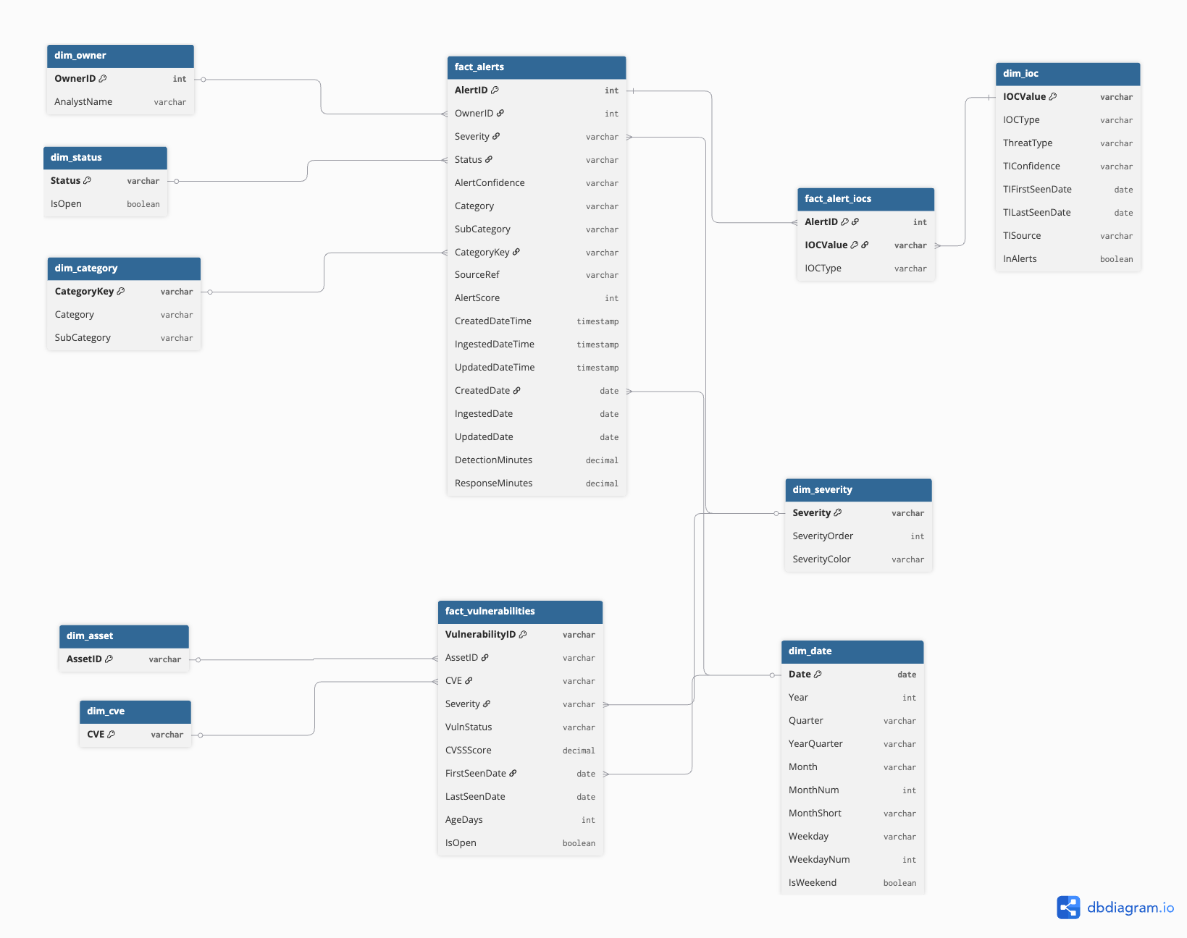

DAX Measures — Semantic Layer
All KPIs are implemented as DAX measures (per the assessment requirement that calculated columns are not used as KPI sources). Measures live in a hidden _Measures table to keep them centrally organized and discoverable in the Fields pane. The four most important measures — the ones explicitly named in the assessment brief — are reproduced below.

MTTD — Mean Time to Detect
Calculated as the average difference between alert ingestion time and alert creation time. The numerator is the DetectionMinutes column computed in Power Query at load time; the measure simply averages it across the current filter context.
dax
MTTD (min) = AVERAGE ( FactAlerts[DetectionMinutes] )

MTTD Display =
VAR _minutes = [MTTD (min)]
RETURN
IF (
ISBLANK ( _minutes ), "—",
IF ( _minutes < 1, FORMAT ( _minutes * 60, "0.0" ) & " sec",
IF ( _minutes < 60, FORMAT ( _minutes, "0.0" ) & " min",
FORMAT ( _minutes / 60, "0.00" ) & " hrs" ))
)

Alert Volume by Severity
Implemented as four individual measures (one per severity level) plus an aggregate "% High or Critical" measure. Filtering uses Dim_Severity rather than Fact_Alerts directly, which propagates through the model more cleanly and is faster.
dax
Total Alerts = COUNTROWS ( FactAlerts )

Critical Alerts =
CALCULATE ( [Total Alerts], DimSeverity[Severity] = "Critical" )

High Alerts =
CALCULATE ( [Total Alerts], DimSeverity[Severity] = "High" )

Medium Alerts =
CALCULATE ( [Total Alerts], DimSeverity[Severity] = "Medium" )

Low Alerts =
CALCULATE ( [Total Alerts], DimSeverity[Severity] = "Low" )

% High or Critical =
DIVIDE ( [Critical Alerts] + [High Alerts], [Total Alerts], 0 )

Escalation Rate
The dataset does not contain an explicit "Escalated" status value. After evaluating four candidate definitions (status-based, severity-based, playbook-based, score-threshold), the implemented definition is: severity is High or Critical AND status is not Closed. This produces a semantically meaningful operational metric and is documented in the assumptions notes.
dax
Escalated Alerts =
CALCULATE (
[Total Alerts],
DimSeverity[Severity] IN { "High", "Critical" },
DimStatus[Status] <> "Closed"
)

Escalation Rate = DIVIDE ( [Escalated Alerts], [Total Alerts], 0 )

MTTR — Average Resolution Time
Companion to MTTD, measured as the average of (UpdatedDateTime − CreatedDateTime). On the synthetic dataset this returns a constant 5 minutes; on real data it would vary meaningfully.
dax
MTTR (min) = AVERAGE ( FactAlerts[ResponseMinutes] )

MTTR Display =
VAR _minutes = [MTTR (min)]
RETURN
IF ( _minutes < 60, FORMAT ( _minutes, "0.0" ) & " min",
FORMAT ( _minutes / 60, "0.00" ) & " hrs" )

Dashboard Details (Charts and Kpi-s)

KPI Summary Tiles (Top Section)
- Total Alerts — the headline number, displayed in amber to draw the eye first.
- % High or Critical — share of the alerting workload that is most severe.
- Escalation Rate — proportion of alerts that meet the operational escalation criteria.
- Avg Resolution Time — MTTR displayed in human-readable units.
- Open Critical Vulns — count of unpatched critical vulnerabilities (the "fix-first" bucket).

Visualizations
Visual | Description | Underlying measure(s)
Alert Volume Over Time | Time-series line chart showing alert creation volume. Single amber line, area-filled below. On this dataset all alerts fall on 2026-05-05, so hourly grouping is used to expose variance. | Total Alerts on DimDate axis
Volume by Severity | Donut chart with severity-colored slices and total in the center hole. Reads severity distribution at a glance. | Total Alerts by DimSeverity[Severity]
Top 10 Assets by Open Vulnerabilities | Horizontal bar chart, all bars in red to signal urgency. Identifies the assets carrying the most unpatched risk. | Open Vulns by DimAsset[AssetID], Top 10

Operational Detail Page
Audience: SOC analysts and vulnerability managers. Designed as a workspace, not a story. Persistent filter rail on the left, dense data tables for triage, and cross-visual filtering enabled by default.

Filter Panel (Left Rail)
- Date range — slider, two-handle Between style
- Severity — tile-style buttons (Critical / High / Medium / Low)
- Status — tile-style buttons (Open / In Progress / Closed)
- Category — dropdown (Authentication / Endpoint / Malware / Network)
- Threat Type — dropdown (Scanner / Botnet / C2 / blank)
- Clear all filters — bookmark-driven reset button

KPI Tiles (Top Strip)
- Open Alerts — operational headline in amber: how big is the analyst's queue?
- Critical Alerts — what needs urgent attention?
- Avg Detection Time (MTTD) — the prescribed KPI from the assessment brief.
- Unique IOCs — distinct count of indicators across all alerts.

Visualizations

Visual | Description | Underlying measure(s)
Alerts by Category and Severity | Horizontal stacked bar; categories on Y-axis, severity-colored segments stacked within each bar. Answers "where is the workload, and how severe is it?" | Total Alerts by DimCategory × DimSeverity
Alert Pipeline by Severity | 100% stacked column. Each severity gets a column; segments show the Open / In Progress / Closed mix as percentages. Pipeline workflow reads bottom-up: green (done) → orange (in flight) → red (urgent). | Total Alerts by DimSeverity × DimStatus, X-axis as % of grand total
Top IOCs by Alert Volume | Sortable table listing the most-alerted IOCs alongside TI enrichment columns. On this dataset, the TI columns are blank — surfacing the zero-overlap finding as visible evidence. | Alerts per IOC by DimIOC, filtered to InAlerts = TRUE
Open Vulnerabilities Detail | Sortable analyst table of unpatched vulnerabilities, ordered by CVSS descending. Severity column conditional-formatted by severity color. | FactVulnerabilities filtered to IsOpen = TRUE

Deliverables
- Documentation of logical, and physical data models
- PBI dashboard visualizations showcasing insights from the data:

PBI report:
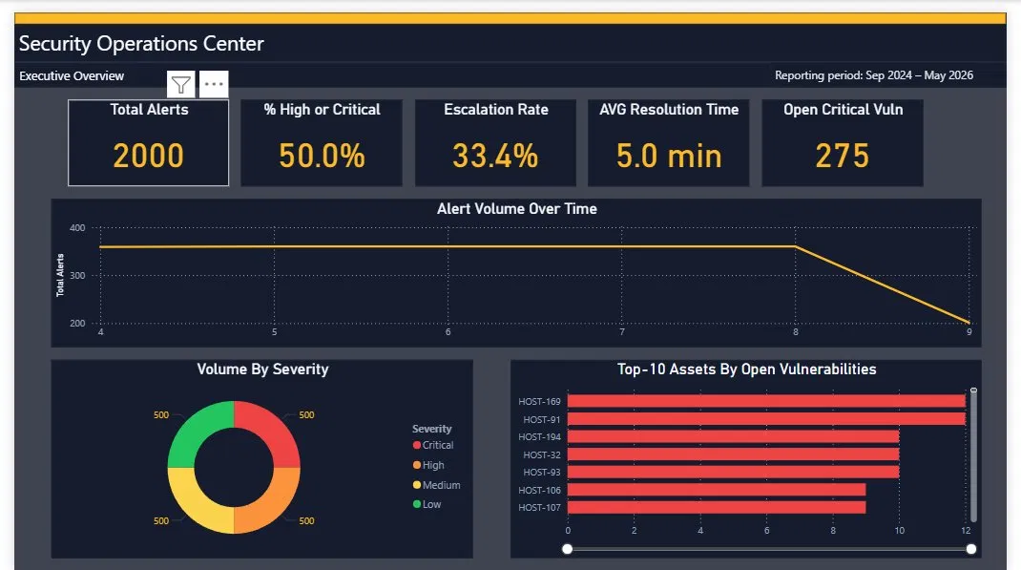
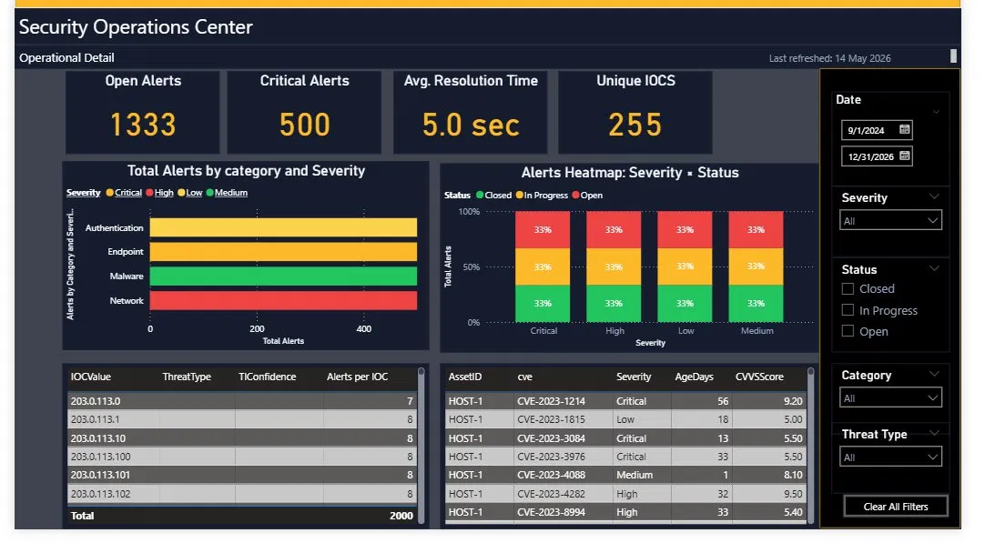
https://app.powerbi.com/groups/me/reports/26239c61-3cf4-4065-9782-4ca798423928/28302d4723292a39a994?experience=power-bi

